*invites you to this autumns*

General Assembly

*on the date of*

November 15th 17:00

*at*

Escape

Dear volunteers, students & members,

On **Wednesday November 15th, at 17:00**, Cybernetisk Selskab will be having this autumn's General Assembly in Escape, Ole-Johan Dahl's house. Everyone is invited, all students at Ifi and/or members of Cybernetisk Selskab can run for office while anyone holding a valid membership before November 8th can vote. There will also be the traditional cured meats offered afterwards.

If you wish to vote at the general assembly the last opportunity to become a member is in the café on **Wednesday November 8th, between 10:00 and 15:15**.

At the General Assembly our Chairman and General Manager of Escape will summarise the autumn term and answer any questions. Our Treasurer will present information about our financial developments, and the assembly will conclude with an election of new board members.

# Preliminary agenda

* Term report
* Accounting
* Budget
* Membership fee
* Election

Updates regarding the programme will be distributed before Wednesday November 8th, at 17:00.

This term’s general assembly has the entirety of the basement board positions up for election, as well as most duties on the executive board. We need talented and dedicated people who can drive this organisation forwards!

# Positions up for election

## Executive board

*All positions on the executive board are by default elected for a period of two university terms.*

* General Manager of Escape
* Treasurer
* Event Manager
* Publicity Manager
* Head of Volunteers

## Basement board

* Financial Administrator (2 terms)
* Head of Purchases
* Bar Manager
* Café Manager
* Equipment Manager
* DJ Manager
* Booking Manager
* Event Coordinator *(TBC)*

If you would like to know more about the different positions and what they entail, you can either ask me or send an email to [hs@cyb.no](mailto:hs@cyb.no).

If you would like to propose amendments to our by-laws, please send them to [hs@cyb.no](mailto:hs@cyb.no) before the deadline **Monday November 13th, at 17:00**. Our current by-laws can be found here: [http://vedtekter.cyb.no](http://vedtekter.cyb.no/).

If you have any further questions, please get in touch via [leder@cyb.no](mailto:leder@cyb.no).

Looking forward to seeing you all there!



Kind regards,

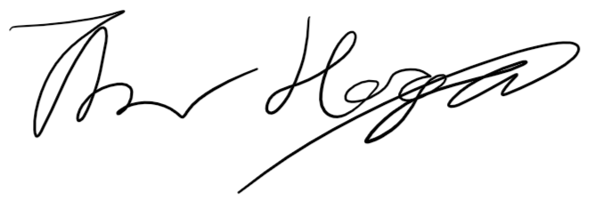

Thor K. Høgås

Deputy Chairman at Cybernetisk Selskab